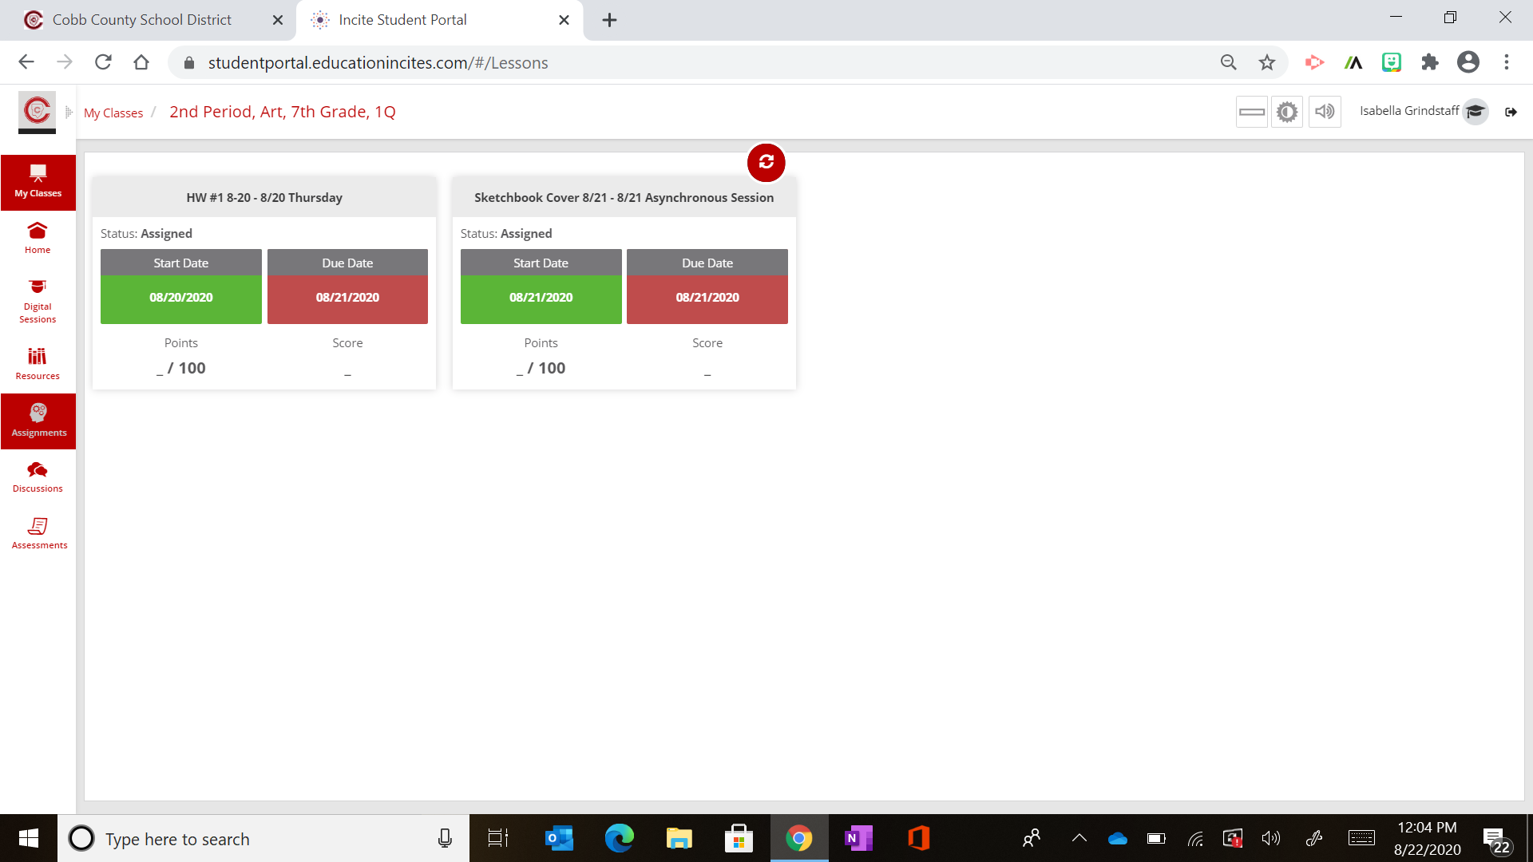

Take a photo of your work and then save it on your device.

Click on the assignment you want to work on.

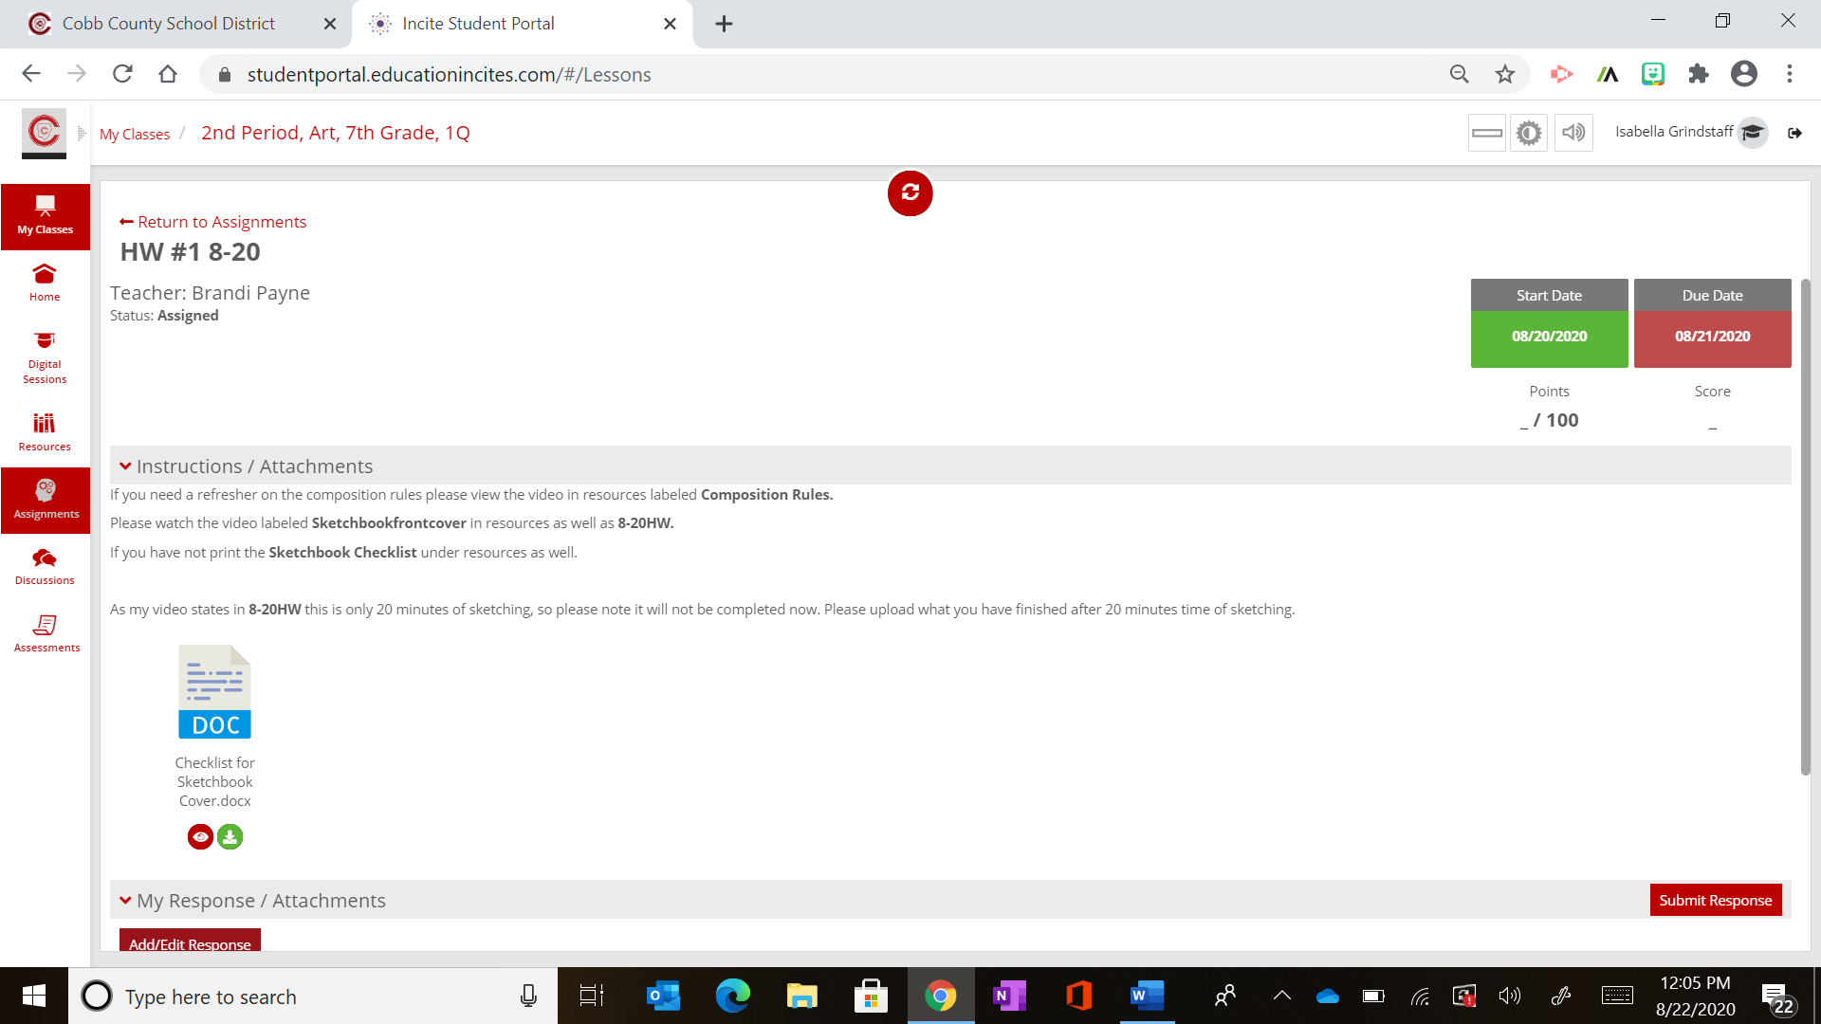

Scroll down to the bottom of the assignment.

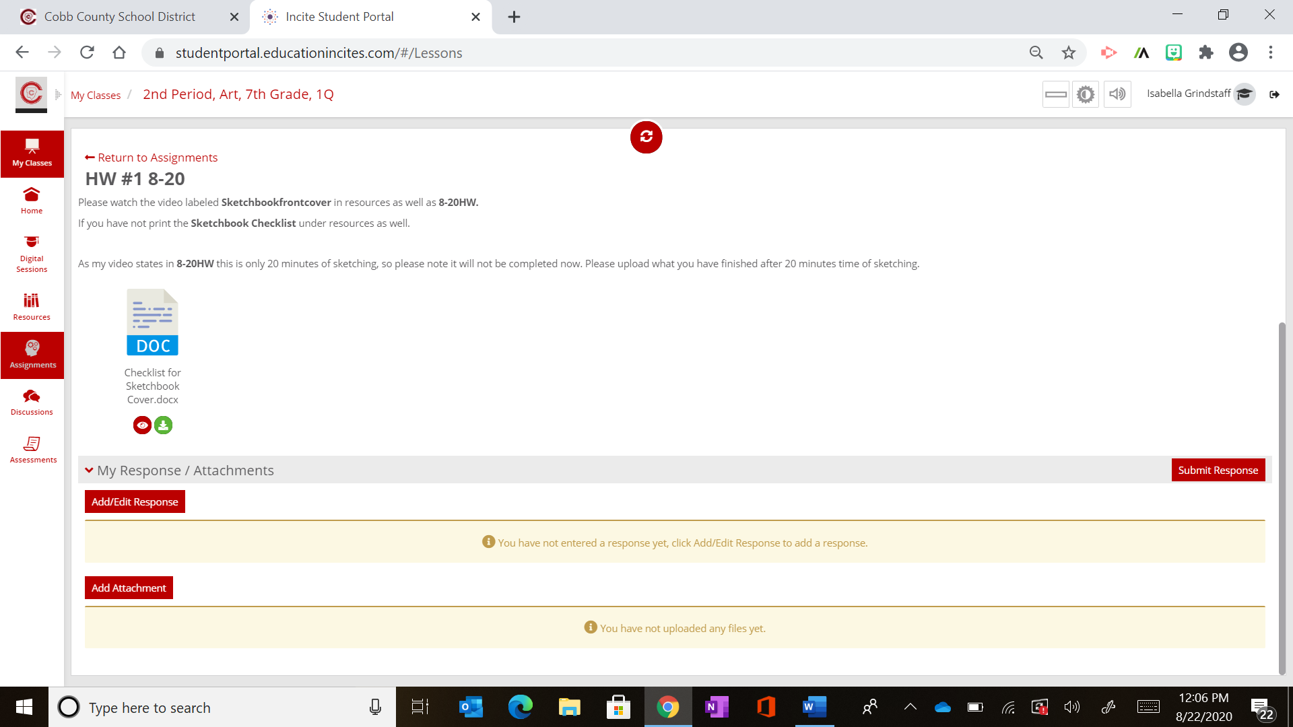

Click add/edit response. To write a response to me, if needed.

Scroll down and then click on Add Attachment.

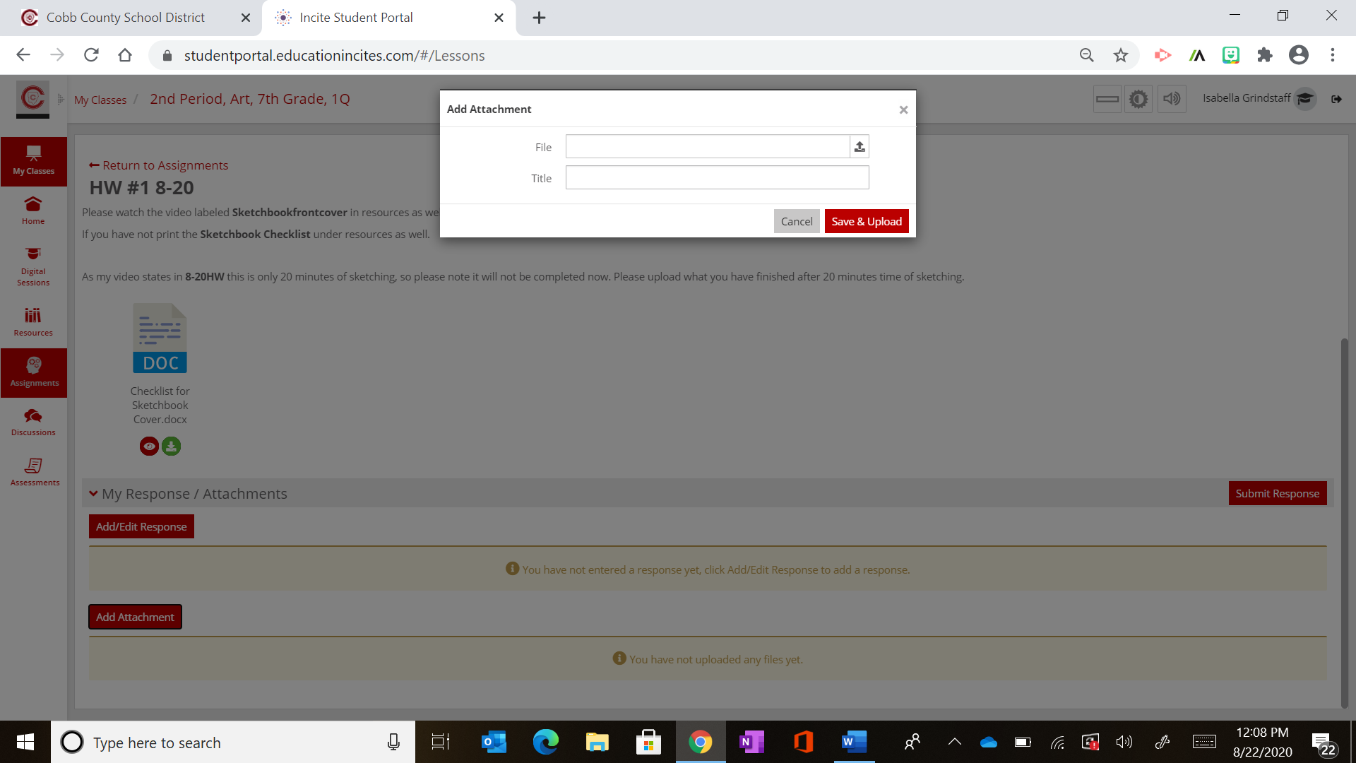

Located your file and then click on the Save & Upload button.

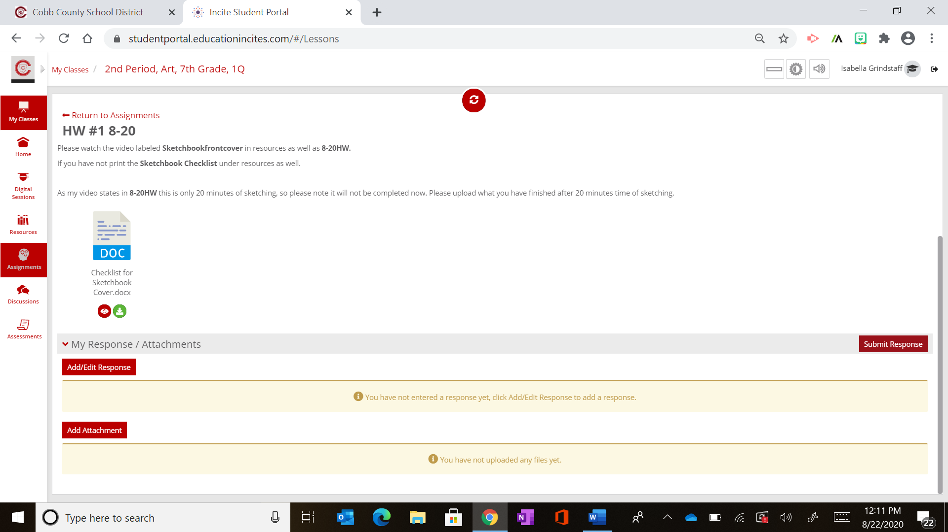

Finally click the Submit Response button.